Understanding

1. This document explains about collecting information from requestee.
2. There are fix logic which will be hard coded like age and other parameters.

Queries

1. What is the meaning user status = “Active” and User Type = “Health Care Assistant”
2. Where would you like to store the documents (e.g. CV, Passport)? Cloud bucket/server/Database?
3. What should happen after filling the form? Any email or **Thank You** page who is filling form.
4. How Admin will see the filled page result?
5. Does Any login screen required to see the results?

**Responses from the client**

1. We can make as configurable parameters for age based on country will be useful, but let’s see not a hard requirement

2. Please ignore (user status =Active and user type =healthcare )that is a sample screen

3. We can assume storing documents in azure blob storage or Amazon s3bucket

4. We should collect all the info store in a cloud storage , we can save the data in azure storage table and blob storage then email the collecte details to admin. For the requestee we can show thank you page

4. Yes we can give sample search page with results. We can give date and country filter :- this is optional client did not ask

5. Yes for admin we can keep a simple admin login

**High level estimation:**

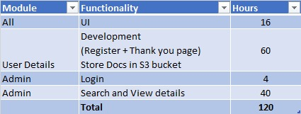

**Architecture Diagram**

